**Lab 1 – Linux Paths**

Login to your account at <https://pwn.college/> .

**Lab submission**: Add screenshots for each challenge below. Take the screenshot of the terminal window where you are awarded the flag. (“Here is your flag {pwn.college ... }

**Name: Carlos Rodriugez CSCI 400 01**

**pwn.college username: Carlos**

**Part 1 – Linux Luminarium – Paths**

Link to Dojo: <https://pwn.college/linux-luminarium/paths/>

Complete the following challenges:

1. The Root
   1. A screenshot of a computer

      AI-generated content may be incorrect.
2. Program and absolute paths
   1. A screenshot of a computer

      AI-generated content may be incorrect.
3. Position thy self
   1. 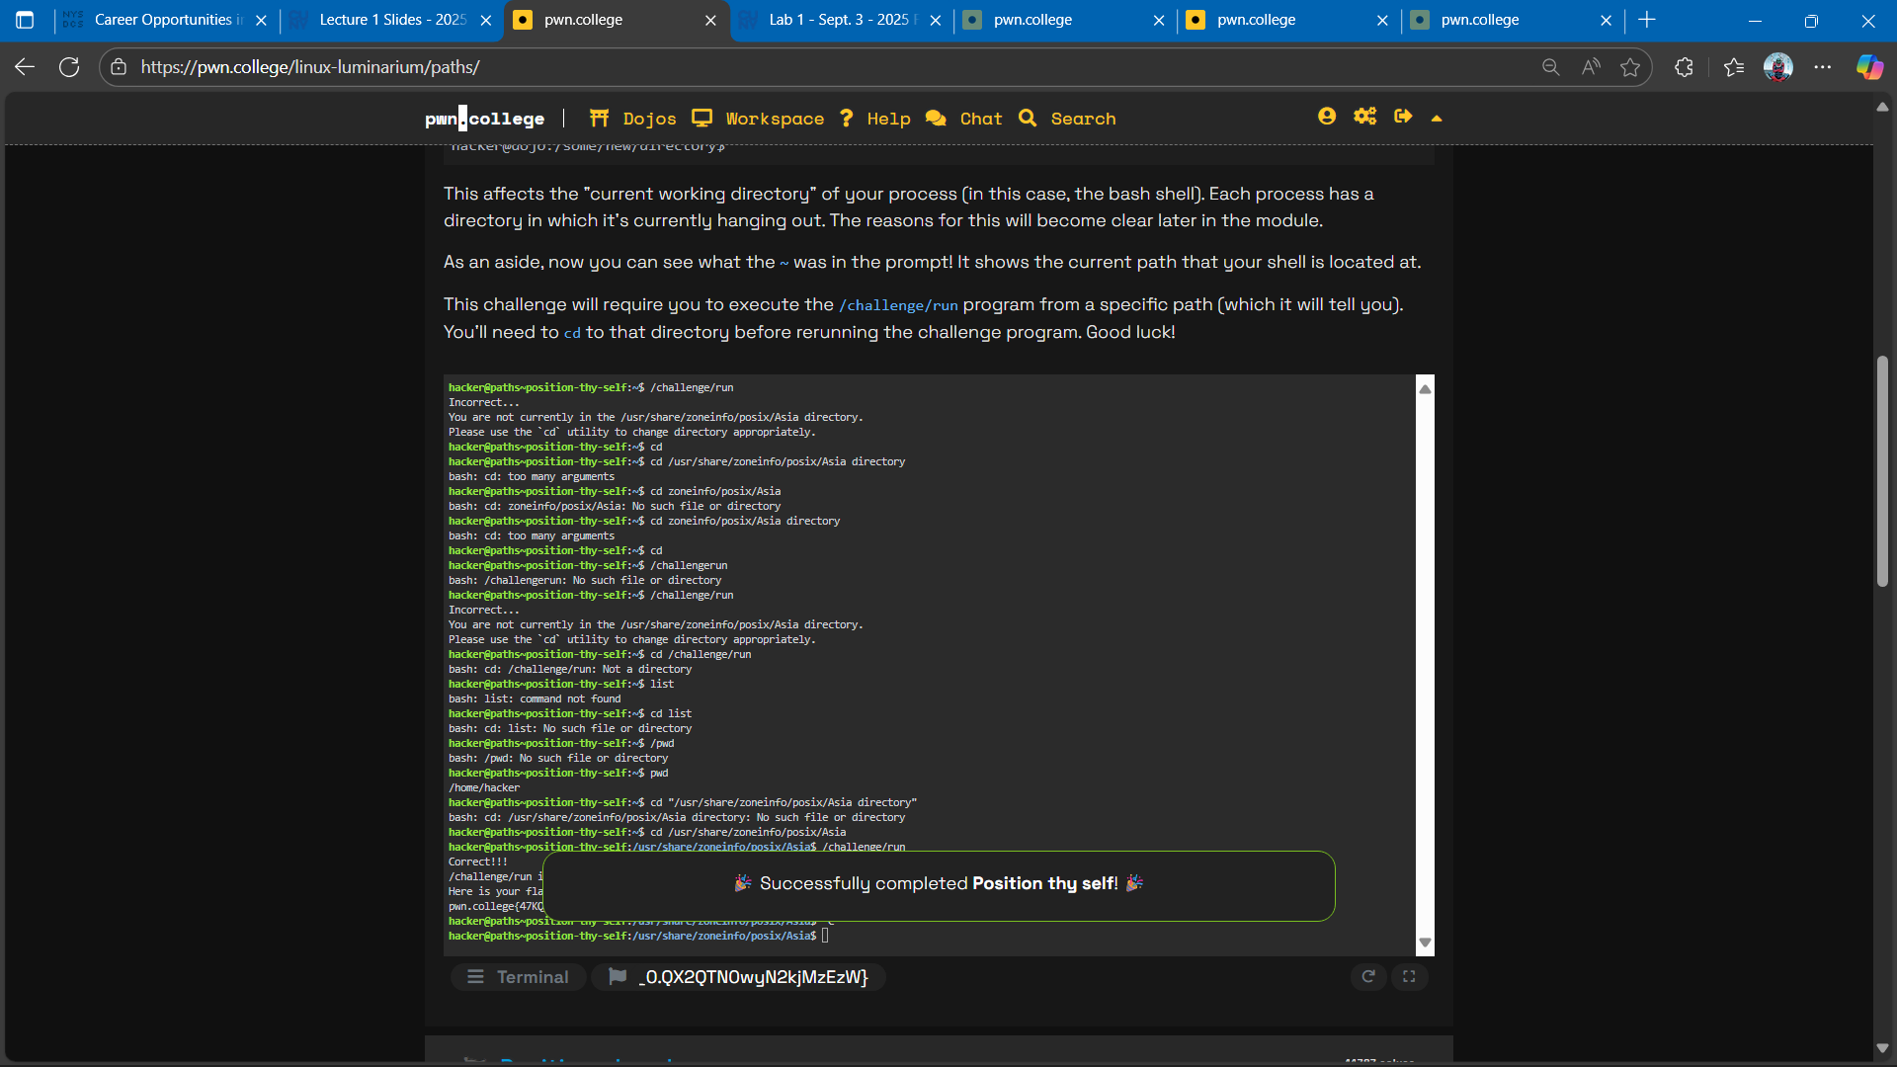
4. Position elsewhere
   1. A screenshot of a computer

      AI-generated content may be incorrect.
5. Position yet elsewhere
   1. A screenshot of a computer

      AI-generated content may be incorrect.
6. Implicit relative paths, from /
   1. A screenshot of a computer

      AI-generated content may be incorrect.
7. Explicit relative paths, from /
   1. A screenshot of a computer

      AI-generated content may be incorrect.
8. Implicit relative path
   1. A screenshot of a computer

      AI-generated content may be incorrect.
9. Home sweet home

***Alternate Part 1***

If you’ve taken the Linux class or already are familiar with navigating paths in Linux, you can start on a more advanced challenge:

Link to Dojo: <https://pwn.college/linux-luminarium/shenanigans/>

Complete the following challenges:

* Bashrc backdoor
* Sniffing Input